**CAP 350 - Data Engineering - Capstone Project Requirements**

**Overview:**

This capstone project is your opportunity to demonstrate the knowledge and abilities you have acquired throughout the course.

This Capstone Project requires learners to work with the following technologies to manage an ETL process for a **Loan Application dataset** and a **Credit Card dataset**: Python (Pandas, advanced modules, e.g., Matplotlib), SQL, Apache Spark (Spark Core, Spark SQL), and Python Visualization and Analytics libraries. Learners are expected to set up their environments and perform installations on their local machines.

# **Capstone Project Submission Guidelines.**

* Your project should result in a .py PYTHON file that can be run from a console. You can work in a notebook while developing your project, but you must export it to a .py file that works appropriately. We ***expect*** this file to be fully functional when you demo your final project.
* GitHub Requirements:
* Create a new repository and ensure all files pertaining to your capstone are in the repository. It must include all notebooks, Python code files, PySpark code files, database scripts, and databases that are part of the project repo.
* Your repository needs to have at least one additional branch off the main branch.
* You must have a properly configured and working git ignore file, and any sensitive files (*credentials,* etc.) are included properly.
* You must include a properly formatted and effective readme markdown file that explains your project. Take a look at other GitHub repos (good quality ones) and reference their readme files for what it should/could look like for your capstone. It MUST include the following:
  + documenting the project details and development comments.
  + documenting technical challenges, along with how they were resolved.
* You must have a minimum of three commits with properly implemented commit messages and descriptions.
* VS Code Environment Requirements
* You should have a new VS Code workspace for your Capstone project
* You should have proper source code management working within VS Code. You should have your VS Code connected to your GitHub repo!
* Your files should be properly named and organized.
* You should create a properly configured and functional virtual environment and requirements file.
* Submit the GitHub repository link (it will need to be a PUBLIC repo for us to be able to review it) AND a zipped copy of your entire repo to the Canvas assignment.

## All learners should schedule a time slot for their project walk-through.

## Workflow Diagram of the Requirements.

The workflow below will help you understand the application's requirements and flow.

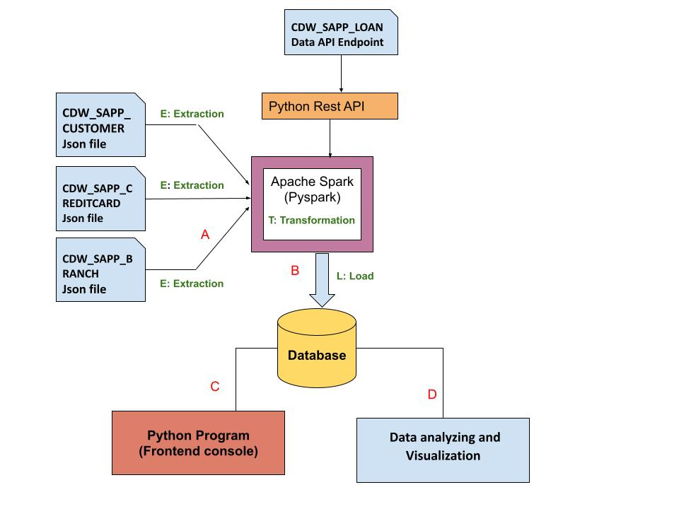

## Credit Card Dataset Overview.

The Credit Card System database is an independent system developed for managing activities such as registering new customers and approving or canceling requests, etc., using the architecture.

A credit card is issued to users to enact the payment system. It allows the cardholder to access financial services in exchange for the holder's promise to pay for them later. Below are three files that contain the customer’s transaction information and inventories in the credit card information.

1. **CDW_SAPP_CUSTOMER.JSON:** This file has the existing customer details.
2. **CDW_SAPP_CREDITCARD.JSON**: This file contains all credit card transaction information.
3. **CDW_SAPP_BRANCH.JSON:** Each branch’s information and details are recorded in this file.

[Click here to download the Credit Card system files](https://drive.google.com/drive/folders/1J4a2UndLvVWszHAL2VxJeVXyAHm3xYIp?usp=sharing).

## Business Requirements - ETL

### 1. Functional Requirements - Load Credit Card Database (SQL)

|  |  |
| --- | --- |
| **Req-1.1** | **Data Extraction and Transformation with Python and**  **PySpark** |
| **Functional Requirement 1.1** | 1. For **“Credit Card System,”** create a Python and PySpark SQL program to **read/extract** the following JSON files **according to the specifications found in the** [**mapping document**](https://docs.google.com/spreadsheets/d/1t8UxBrUV6dxx0pM1VIIGZpSf4IKbzjdJ/edit?usp=sharing&ouid=109108037194607248998&rtpof=true&sd=true)**.**     1. CDW_SAPP_BRANCH.JSON  2. CDW_SAPP_CREDITCARD.JSON  3. CDW_SAPP_CUSTOMER.JSON  **Note**: **Data Engineers will be required to transform the data based on the requirements found in the** [**Mapping Document.**](https://docs.google.com/spreadsheets/d/1t8UxBrUV6dxx0pM1VIIGZpSf4IKbzjdJ/edit?usp=sharing&ouid=109108037194607248998&rtpof=true&sd=true)  Hint: [You can use PySQL “select statement query” or simple Pyspark RDD]. |
| **Req-1.2** | **Data loading into Database** |
| **Function Requirement 1.2** | Once PySpark reads data from JSON files, and then utilizes Python, PySpark, and Python modules to load data into RDBMS(SQL), perform the following:     1. Create a Database in SQL(MySQL), named **“creditcard_capstone.”** 2. Create a Python and Pyspark Program to load/write the “Credit Card System Data” into RDBMS(**creditcard_capstone**).   Tables should be created by the following names in RDBMS:  ***CDW_SAPP_BRANCH***  ***CDW_SAPP_CREDIT_CARD***  ***CDW_SAPP_CUSTOMER*** |

### 

### 2. Functional Requirements - Application Front-End

Once data is loaded into the database, we need a front-end (console) to see/display data. For that, create a **console-based Python program** to satisfy System Requirements 2 (2.1 and 2.2).

**2.1 Transaction Details Module**

|  |  |
| --- | --- |
| **Req-2.1** | **Transaction Details Module** |
| **Functional Requirements 2.1** | 1)Used todisplay the transactions made by customers living in a given zip code for a given month and year. Order by day in descending order.  2) Used to display the number and total values of transactions for a given type.  3) Used to display the total number and total values of transactions for branches in a given state. |

**2.2 Customer Details Module**

|  |  |
| --- | --- |
| **Req-2.2** | **Customer Details** |
| **Functional Requirements 2.2** | 1) Used to check the existing account details of a customer.  2) Used to modify the existing account details of a customer.  3) Used to generate a monthly bill for a credit card number for a given month and year.  4) Used to display the transactions made by a customer between two dates. Order by year, month, and day in descending order. |

### 3. Functional Requirements - Data Analysis and Visualization

After data is loaded into the database, users can make changes from the front end, and they can also view data from the front end. Now, the business analyst team wants to analyze and visualize the data.

Use Python libraries for the below requirements:

|  |  |
| --- | --- |
| **Req - 3** | **Data Analysis and Visualization** |
| **Functional Requirements 3.1** | Find and plot which transaction type has the highest transaction count. Note: Save a copy of the visualization to a folder in your github, making sure it is PROPERLY NAMED! |
| **Functional Requirements 3.2** | Find and plot which state has a high number of customers.  Note: Save a copy of the visualization to a folder in your github, making sure it is PROPERLY NAMED! |
| **Functional Requirements 3.3** | Find and plot the sum of all transactions for the top 10 customers, and which customer has the highest transaction amount.  Hint (use CUST_SSN).  Note: Save a copy of the visualization to a folder in your github, making sure it is PROPERLY NAMED! |

## Overview of LOAN Application Data API

Banks deal in all home loans. They have a presence across all urban, semi-urban, and rural areas. Customers first apply for a home loan; after that, a company will validate the customer's eligibility for a loan.

Banks want to automate the loan eligibility process (in real time) based on customer details provided while filling out the online application form. These details are Gender, Marital Status, Education, Number of Dependents, Income, Loan Amount, Credit History, and others. To automate this process, they have the task of identifying the customer segments to those who are eligible for loan amounts so that they can specifically target these customers. Here they have provided a partial dataset.

**API Endpoint:** <https://raw.githubusercontent.com/platformps/LoanDataset/main/loan_data.json>

The above URL allows you to access information for loan application information. This dataset has all of the required fields for a loan application. You can access data from a REST API by sending an HTTP request and processing the response.

### 4. Functional Requirements - LOAN Application Dataset

|  |  |
| --- | --- |
| **Req-4** | **Access to Loan API Endpoint** |
| **Functional Requirements 4.1** | Create a Python program to GET (consume) data from the above API endpoint for the loan application dataset. |
| **Functional Requirements 4.2** | Find the status code of the above API endpoint.  Hint: status code could be 200, 400, 404, 401. |
| **Functional Requirements 4.3** | Once Python reads data from the API, utilize PySpark to load data into RDBMS (SQL). The table name should be **CDW-SAPP_loan_application** in the database.  Note: Use the **“creditcard_capstone”** database**.** |

### 5. Functional Requirements - Data Analysis and Visualization for LOAN Application

After the data is loaded into the database, the business analyst team wants to analyze and visualize the data.

Use Python libraries for the below requirements:

|  |  |
| --- | --- |
| **Req-5** | **Data Analysis and Visualization** |
| **Functional Requirements 5.1** | Find and plot the percentage of applications approved for self-employed applicants. Note: Save a copy of the visualization to a folder in your github, making sure it is PROPERLY NAMED! |
| **Functional Requirements 5.2** | Find the percentage of rejection for married male applicants. Note: Save a copy of the visualization to a folder in your github, making sure it is PROPERLY NAMED! |
| **Functional Requirements 5.3** | Find and plot the top three months with the largest volume of transaction data. Note: Save a copy of the visualization to a folder in your github, making sure it is PROPERLY NAMED! |
| **Functional Requirements 5.4** | Find and plot which branch processed the highest total dollar value of healthcare transactions. Note: Save a copy of the visualization to a folder in your github, making sure it is PROPERLY NAMED!. |

**References:**

**Example CLI Project:**

https://realpython.com/python-typer-cli/

PySpark:  
<https://spark.apache.org/docs/latest/api/python/index.html>

Apache Spark - Spark SQL:  
<https://spark.apache.org/sql/>

Analyzing and Visualization:

<https://www.analyticsvidhya.com/blog/2021/08/understanding-bar-plots-in-python-beginners-guide-to-data-visualization/>